**An UML Virtual Machine based on AST execution**

Software Engineer Bruno Buzzi Brassesco – Reviewer VM expert Eliot Miranda

[1]

# Abstract

An UML Virtual Machine (UVM) is a program that executes code based on an UML Class diagram (and an UML State diagram[2]). The code to execute can have any representation like bytecodes, AST or other. The UVM analyze the code representation and creates an execution context in order to perform the code execution.

The UVM has to have the ability to create class instances based on the UML Class diagram and set and get instances’ attributes. Also it has to handle in some way the instantiation of UML Class relations (this UVM implement instances creation and update through UVM primitives and traits).

The code execution performed by the UVM has different types of restrictions defined on the UML Class diagram. For example it is forbidden to assign a string value to an integer attribute of a class.

Classes’ relations are defined by multiplicity on the UML Class diagram. Class A may have a 1:N relation with class B then an instance of class A it will have N instances of class B and each class B it will have only an instance of class A. The UVM has to do some type checks when class instances are being composed. These type checks has to include inheritance of the model too.

To summarize the characteristics of an UVM:

1. A way to import UML Class diagrams.
2. Ability to instantiate the UML Class diagram.
3. Basic building blocks to create complex operations in 4.
4. Ability to create code and code representation.
5. Ability to create context execution to perform code execution.

In order to support these five points it is very desirable to have a development environment to perform each activity.

# INTRODUCTION

In the present case the implemented UVM comply with these five points and there is also a development environment to create simulations.

1. UML Class diagrams are imported through XMI 2.1 interface used by any UML Case tool such as Visual Paradigm, Enterprise Architect and so on ...
2. The UML Class diagram instantiation is supported by a powerful Meta Model.
3. The UVM has a basic hierarchy of classes to allow the creation of much more complex functionality.
4. The code representation is done with an AST (abstract syntax tree) using a Smalltalk Parser to transform a text into an AST.
5. Execution Context is implemented as Smalltalk classes and is part of the core of the UVM.

The UVM was named U-Fabrik and was totally implemented in [Dolphin Smalltalk](https://github.com/dolphinsmalltalk/Dolphin) and the code can be found at:

<https://github.com/brunobuzzi/U-Fabrik>

# U-Fabrik Architecture

The following image depict a general architecture of the whole U-Fabrik environment including the UML Virtual Machine.

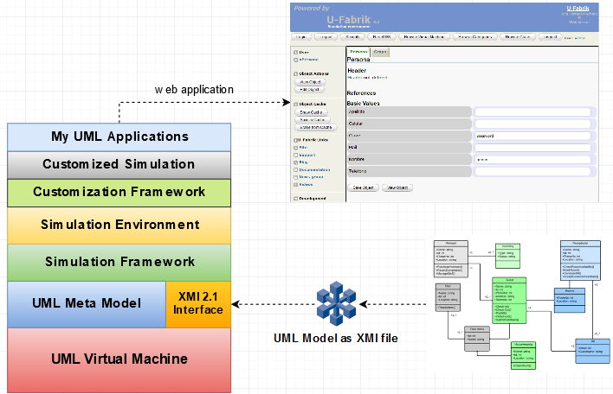

The XMI 2.1 interface used to import XMI files from Enterprise Architect®, Visual Paradigm®, and so on. The Meta Model used to represent all elements contained in the XMI file. The UML Virtual Machine to simulate behavior through message sending. On the top of the UML Virtual Machine it has a Graphical Environment for prototyping and simulation. The default web prototype is done automatically (after the XMI installation). The Customization Framework combines the Simulation Framework and Simulation Environment to achieve customization through method implementations and drag & drop operations.

# U-Fabrik Virtual Machine (UVM)

U-Fabrik Virtual Machine objects are wrapped around Smalltalk objects. Each UVM object is an instance of Smalltalk class UMLVirtualMachineInstance. This class has an instance variable named “smalltalkObject” which holds the actual Smalltalk object.

All basic classes of the U-Fabrik Virtual Machine are instances of UMLVirtualMachineClass and are instantiated as instances of UMLVirtualMachineInstance where “smalltalkObject” points to the actual Smalltalk object.

These classes includes: Object, Block, Boolean (True and False), Collection, Array, Dictionary, Interval, OrderedCollection, Date, Error, Exception Warning, Number, String, Time, TimeStamp, TreeModel and so on.

The following image depict how U-Fabrik objects are connected to *real Smalltalk objects*:

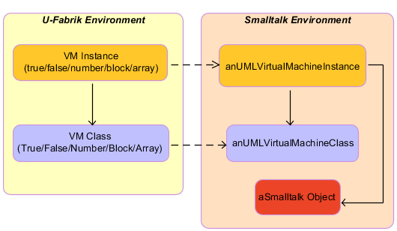 In the U-Fabrik Environment instances of UML Class diagram are instances of Smalltalk class UMLInstance and its class is an instance of UMLClass:

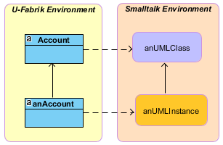

# Virtual Machine Primitives

# code execution

# Blocks

# environment

# Publication Principles

# Conclusion

Appendix A: Why and how UVM was created

A big project for a government (in 2009) with 10 functional analyst (from company A) and 20 programmers (from company B) to implement a system with 400 classes or so. By contract the functional analysts (company A) have to produce an UML Model (in Enterprise Architect) and based on the UML Model create Use Cases (as Word Documents) to send it to the programmers (the software factory - company B).

This methodology had a lot of problems, most Use Cases were rejected by the Software Factory because different errors in the UML model. Errors types: referencing a missing class, a missing attribute, missing multiplicity, incompability with other part of the model (when more than one functional analyst were responsible for a Use Case), to name just a few problems.

In order to improve this situation it was visualized that another tool was needed.

The first version was a simple application to import XMI files from Enterprise Architect and display classes, relations and attributes to detect missing UML elements. The rejection of Uses Cases felt dramatically (around 80%).

The second version allow the creation of UML instances in order to dynamically visualize how elements interact with each other. This helped to refine the UML Class diagram and improve the Uses Cases creation.

The third version added a web interface to show UML instances as a Web Application enabling a much better communication with end users to break down requirements.

The fourth version introduced a mayor change, the support for method execution including Blocks. With this version a Use Case could be executed before been written as Word Document. This assured 100% of accuracy in Uses Cases and saved a lot of time and money.

This last version was truly an UML Virtual Machine that was named U-Fabrik.

U-Fabrik was implemented in Dolphin Smalltalk 6 in 2009 and it was migrated to Dolphin Smalltalk 7.0 in 2018.

Acknowledgment

References

1.
2. If the UML State diagram is defined as classes in the UML Class diagram then the UML Virtual Machine can simulate the State Machine. For more details: <https://github.com/brunobuzzi/U-Fabrik/wiki/State-Machine-Import>